**Experiment-5 DT-23.10.2020**

**Aim of the experiment:**

Designing and verification of 4:1 multiplexer and 1:4 de-multiplexer.

**Apparatus required :**

1. Tinkercad software
2. Breadboard
3. IC based on the gates used-74hc04,74hc11
4. Power supply- voltage: 5V,current: 5A
5. Switches-(DIP SPST x6,x4 SWITCH)
6. LED
7. Resistor: 1k ohm
8. Connecting wires

**Theory:**

1. 4:1 MUX-

A 4-to-1 multiplexer consists four data input lines as D0 to D3, two select lines as S0 and S1 and a single output line Y. The select lines S1 and S2 select one of the four input lines to connect the output line. The particular input combination on select lines selects one of input (D0 through D3) to the output.

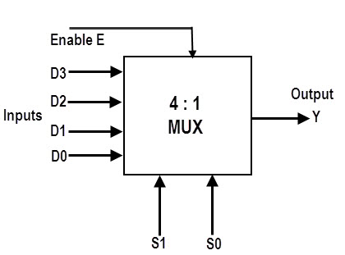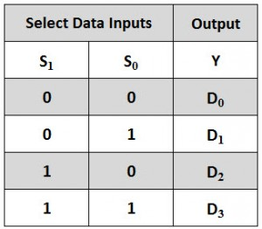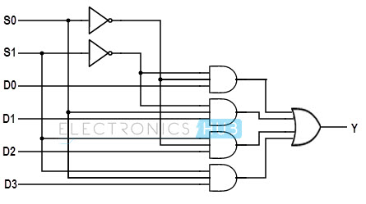

2.

1:4 DEMUX-

A 1-to-4 demultiplexer has a single input (D), two selection lines (S1 and S0) and four outputs (Y0 to Y3). The input data goes to any one of the four outputs at a given time for a particular combination of select lines.

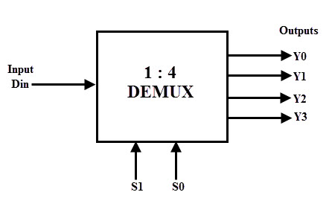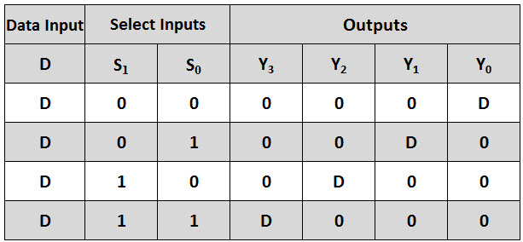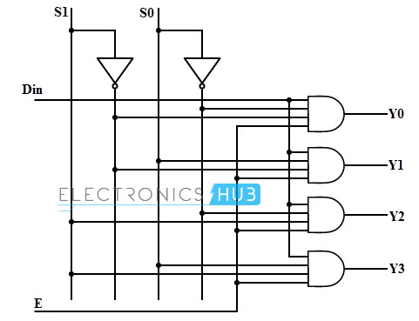

**Observations:**

1. 4:1 MUX-

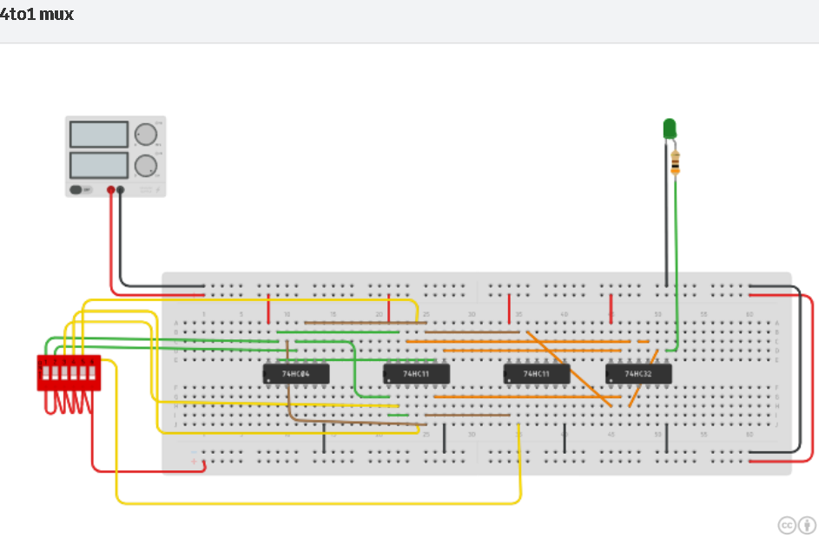

1:4 DEMUX-

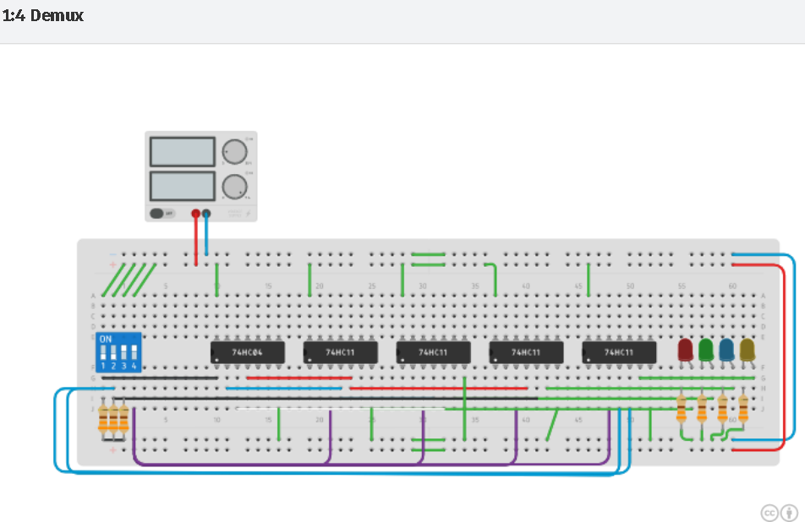

**Conclusion:**

4:1 multiplexer and 1:4 de-multiplexer circuits were designed and tested successfully.

**Name- HARSH KUMAR**

**SID- B219027**

**Branch- Computer Engineering (CE)**